Insert your name, centre number and candidate number into the header above.
Save this evidence document as evidence_ followed by your centre number_ candidate number. For example: evidence_ zz999_9999.doc
Screenshots or program listings must be copied into appropriate cells in the following tables.
Examiners must be able to read the contents including any screenshots without the use of a magnifying glass. Answers that are not readable or missing will not be awarded any marks.
Save this evidence document at regular intervals, for example, every 10 minutes.
Question 1
Part 1(a)
def ReadWords(file):
global WordArray, NumberWords
try:
with open(file, "r") as f:
Words = f.read().strip()
WordArray = Words.split()
NumberWords = len(WordArray)
except IOError:
print("Error occurred/file not found.")

Part 1(b)
File = input("Enter difficulty: ").lower()
FirstChar = File[0]
NewPrompt = FirstChar.upper() + File[1:len(File)] + ".txt"
ReadWords(NewPrompt)

Part 1(c)(i)
def Play():
global WordArray, NumberWords
print(f"The main word is {WordArray[0]} and there are {NumberWords - 1} answers")
answer = None
answerfound = 0
while answer != "no":
answer = input("Enter a word or no to quit the game: ").lower()
FoundStatus = False
if answer != "no":
for x in range(NumberWords):
if answer == WordArray[x]:
WordArray[x] = ""
answerfound += 1
print(f"Correct, {answerfound} answer so far")
FoundStatus = True
if not FoundStatus:
print("Incorrect")

Part 1(c)(ii)
def Play():
global WordArray, NumberWords
print(f"The main word is {WordArray[0]} and there are {NumberWords - 1} answers")
answer = None
answerfound = 0
while answer != "no":
answer = input("Enter a word or no to quit the game: ").lower()
FoundStatus = False
if answer != "no":
for x in range(NumberWords):
if answer == WordArray[x]:
WordArray[x] = ""
answerfound += 1
print(f"Correct, {answerfound} answer so far")
FoundStatus = True
if not FoundStatus:
print("Incorrect")
if answer == "no":
percentagefound = answerfound / (NumberWords - 1) * 100
print(f"You have found {percentagefound}% of the words")
if percentagefound < 100:
print("Answer missed: ")
for x in range(NumberWords):
if WordArray[x] != "":
print(WordArray[x])

Part 1(d)(i)
def ReadWords(file):
global WordArray, NumberWords
try:
with open(file, "r") as f:
Words = f.read().strip()
WordArray = Words.split()
NumberWords = len(WordArray)
Play()
except IOError:
print("Error occurred/file not found.")

Part 1(d)(ii)
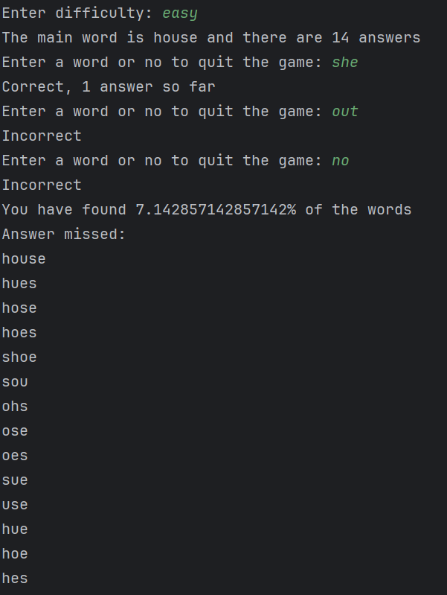

Part 1(d)(iii)
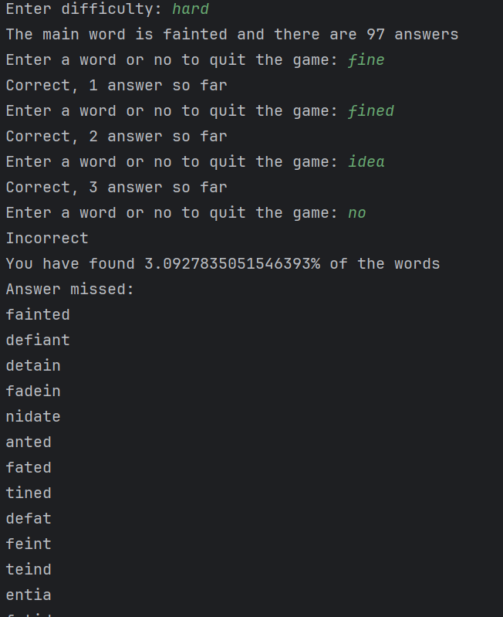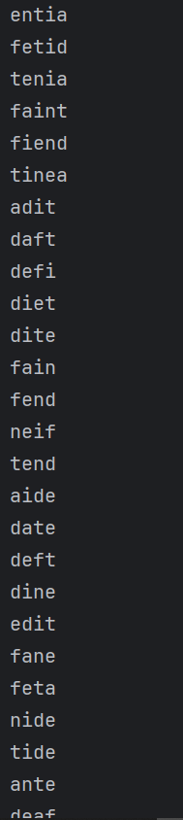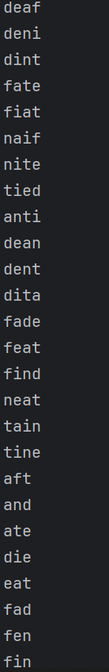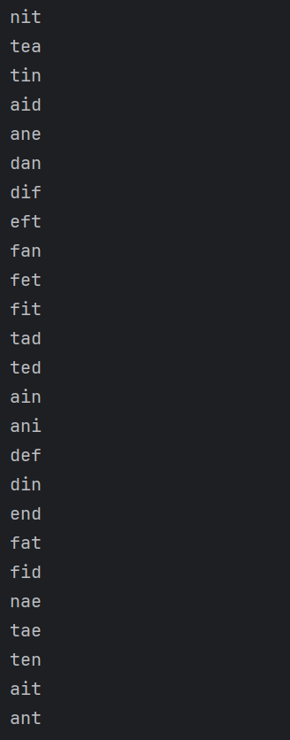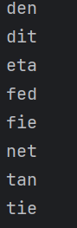

Question 2
Part 2(a)(i)
class Node:
def __init__(self, Data):
self._LeftPointer = -1 # integer
self._Data = Data
self._RightPointer = -1 # integer

Part 2(a)(ii)
def GetLeft(self):
return self._LeftPointer
def GetRight(self):
return self._RightPointer
def GetData(self):
return self._Data

Part 2(a)(iii)
def SetLeft(self, val):
self._LeftPointer = val
def SetRight(self, val):
self._RightPointer = val
def SetData(self, val):
self._Data = val

Part 2(b)(i)
class TreeClass:
def __init__(self):
self._FirstNode = -1
self._NumberNodes = 0
self._Tree = []
for x in range(20):
self._Tree.append(Node(-1))

Part 2(b)(ii)
def InsertNode(self, NewNode):
if self._NumberNodes == 0:
self._Tree[self._NumberNodes] = NewNode
self._NumberNodes += 1
self._FirstNode = 0
else:

Part 2(b)(iii)
def OutputTree(self):
if self._NumberNodes == 0:
print("No nodes")
else:
for x in range(0, self._NumberNodes):
print(self._Tree[x].GetLeft(), self._Tree[x].GetData(), self._Tree[x].GetRight())

Part 2(c)(i)
TheTree = TreeClass()

Part 2(c)(ii)
TheTree.InsertNode(Node(10))
TheTree.InsertNode(Node(11))
TheTree.InsertNode(Node(5))
TheTree.InsertNode(Node(1))
TheTree.InsertNode(Node(20))
TheTree.InsertNode(Node(7))
TheTree.InsertNode(Node(15))
TheTree.OutputTree()

Part 2(c)(iii)
{Copy and paste screenshot for question 2(c)(iii) here}

Question 3
Part 3(a)
NumberArray = [100, 85, 644, 22, 15, 8, 1]

Part 3(b)(i)
def RecursiveInsertion(IntegerArray, NumberElements):
if NumberElements <= 1:
return IntegerArray
else:
RecursiveInsertion(IntegerArray, NumberElements - 1)
LastItem = IntegerArray[NumberElements - 1]
CheckItem = NumberElements - 2
LoopAgain = True
if CheckItem < 0:
LoopAgain = False
elif IntegerArray[CheckItem] < LastItem:
LoopAgain = False
while LoopAgain:
IntegerArray[CheckItem + 1] = IntegerArray[CheckItem]
CheckItem -= 1
if CheckItem < 0:
LoopAgain = False
IntegerArray[CheckItem + 1] = LastItem
return IntegerArray

Part 3(b)(ii)
result = RecursiveInsertion(NumberArray, 7)
print("Recursive", result)

Part 3(b)(iii)

Part 3(c)(i)
def IterativeInsertion(IntegerArray, NumberElements):
while NumberElements > 0:
LastItem = IntegerArray[NumberElements - 1]
CheckItem = NumberElements - 2
LoopAgain = True
if CheckItem < 0:
LoopAgain = False
elif IntegerArray[CheckItem] < LastItem:
LoopAgain = False
while LoopAgain:
IntegerArray[CheckItem + 1] = IntegerArray[CheckItem]
CheckItem -= 1
if CheckItem < 0:
LoopAgain = False
IntegerArray[CheckItem + 1] = LastItem
NumberElements -= 1
return IntegerArray

Part 3(c)(ii)
IterativeResult = IterativeInsertion(NumberArray, 7)
print("Iterative", IterativeResult)

Part 3(c)(iii)

Part 3(d)(i)
def BinarySearch(IntegerArray, First, Last, ToFind):
if First > Last:
return -1
mid = int((First + Last) / 2)
if IntegerArray[mid] == ToFind:
return mid
elif IntegerArray[mid] > ToFind: # ToFind is in the first half of the array
BinarySearch(IntegerArray, First, mid, ToFind)
else: # ToFind is in the second half
BinarySearch(IntegerArray, mid, Last, ToFind)
if IntegerArray[mid] != ToFind:
return -1

Part 3(d)(ii)
Bin = BinarySearch(RecursiveInsertion(NumberArray, 7), 1, 7, 644)
if Bin == -1:
print("Not found")
else:
print(Bin)

Part 3(d)(iii)
